**Fanka Shundovska**

**IntelliJ – JAVA LOOP Extra Homework AT06**

1. You are picking apples from a tree. One basket can hold 23 apples. How many baskets will you need for 100, 230 and 470 apples?

package com.edu.sedc.JavaLoopExtraHomework;  
  
public class PickingApple {  
  
 public static void main(String[] args) {  
  
 int basketCapacity = 23;  
  
 int[] applesToPick = {100, 230, 470};  
  
 for (int apples : applesToPick) {  
 int basketsNeeded = (int) Math.*ceil*((double) apples / basketCapacity);  
 System.*out*.println("For " + apples + " apples, you'll need " + basketsNeeded + " baskets.");  
 }  
 }  
  
}

"C:\Program Files\Java\jdk-11.0.8\bin\java.exe" "-javaagent:C:\Users\Fani\AppData\Local\JetBrains\IntelliJ IDEA Community Edition 2023.3.3\lib\idea_rt.jar=55639:C:\Users\Fani\AppData\Local\JetBrains\IntelliJ IDEA Community Edition 2023.3.3\bin" -Dfile.encoding=UTF-8 -classpath C:\Users\Fani\IdeaProjects\first-project-g1\target\classes com.edu.sedc.JavaLoopExtraHomework.PickingApple

For 100 apples, you'll need 5 baskets.

For 230 apples, you'll need 10 baskets.

For 470 apples, you'll need 21 baskets.

Process finished with exit code 0

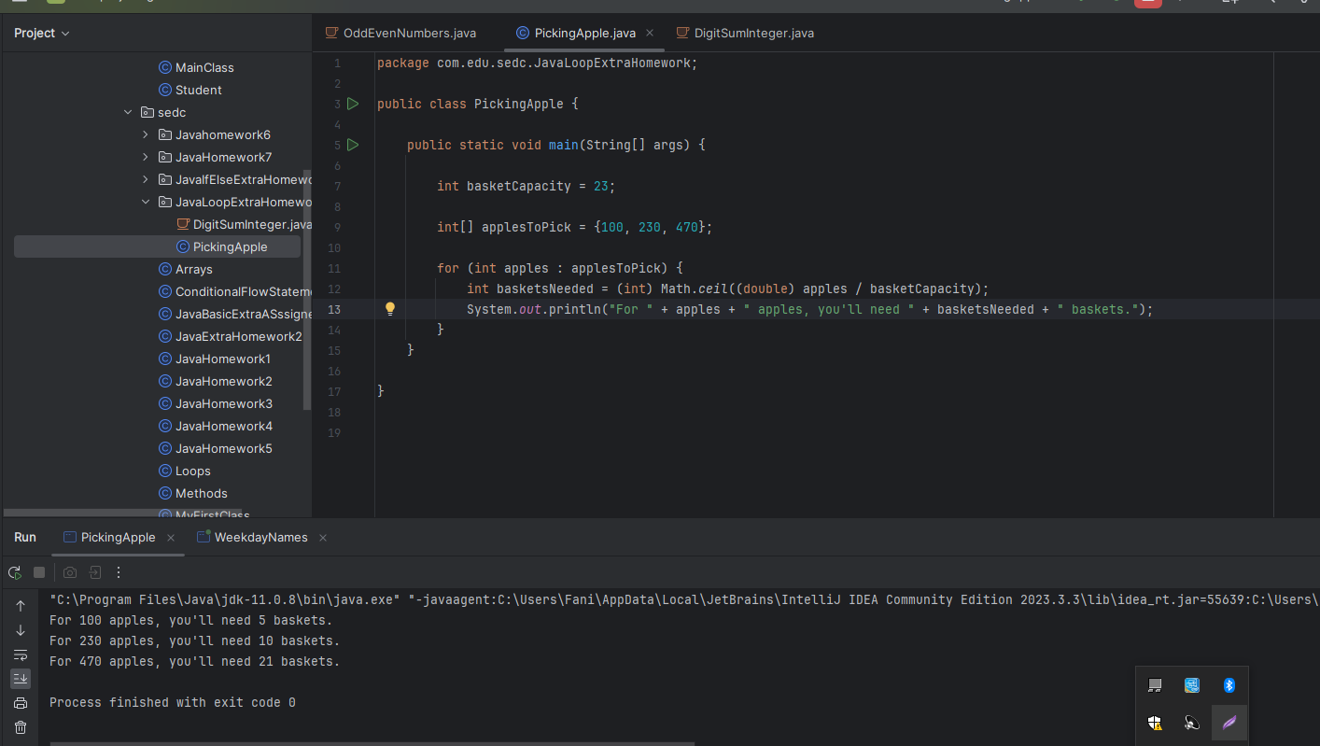

2. Write a Java program to compute the sum of the digits of an integer

package com.edu.sedc.JavaLoopExtraHomework;  
  
import java.util.Scanner;  
  
public class DigitSumInteger1 {  
 public static int calculateDigitSum(int number) {  
 int sum = 0;  
  
 while (number != 0) {  
 sum += number % 10;  
 number /= 10;  
 }  
 return sum;  
 }  
  
 public static void main(String[] args) {  
 int inputNumber = 987654321;  
 int sumOfDigits = *calculateDigitSum*(inputNumber);  
 System.*out*.println("Sum of digits of " + inputNumber + " is: " + sumOfDigits);  
 }  
}

"C:\Program Files\Java\jdk-11.0.8\bin\java.exe" "-javaagent:C:\Users\Fani\AppData\Local\JetBrains\IntelliJ IDEA Community Edition 2023.3.3\lib\idea_rt.jar=49571:C:\Users\Fani\AppData\Local\JetBrains\IntelliJ IDEA Community Edition 2023.3.3\bin" -Dfile.encoding=UTF-8 -classpath C:\Users\Fani\IdeaProjects\first-project-g1\target\classes com.edu.sedc.JavaLoopExtraHomework.DigitSumInteger1

**Sum of digits of 987654321 is: 45**

Process finished with exit code 0

